GY-521 MPU6050 3-Axis Acceleration Gyroscope 6DOF Module - Blue
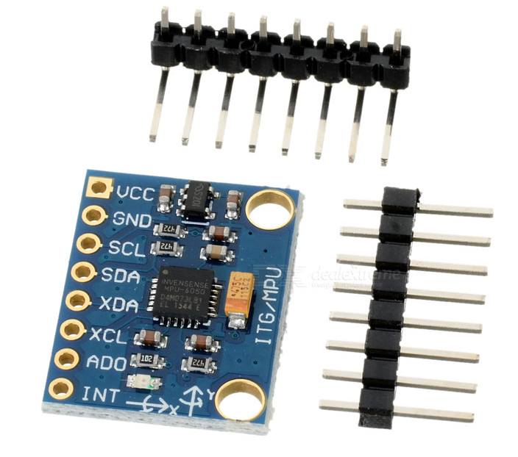
- Model: GY-521
- Color: Blue
- Material: PCB + Plastic + copper
- Chip: MPU-6050
- Power supply: 3~5V
- Communication mode: standard IIC communication protocol
- Chip built-in 16bit AD converter, 16bit data output
- Gyroscopes range: +/- 250 500 1000 2000 degree/sec
- Acceleration range: +/- 2g, +/- 4g, +/- 8g, +/- 16g
- Immersion Gold plating PCB, machine welding process to ensure quality
- Pin pitch: 2.54mm
- Great for DIY projects
- Packing list:
- 1 x Module
- 2 x Pins

